President’s Corner:
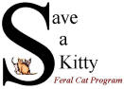
SAVE A KITTY FERAL CAT PROGRAM, INC.

Publisher SAK Volunteers Volume No. 16 Issue No. 3 Date 3rd Qtr 2019
Parkersburg, WV NEWSLETTER www.saveakitty.org

Progress!
Through September 30, 2019 Save a Kitty FCP has helped hundreds of residents who are caring for community cats. We have sterilized and vaccinated 400 cats and kittens through 3rd quarter, 2019. This included 220 female spays and 180 male neuters!!! Talk about impact on cat over-population. Not only are these felines no longer reproducing but they are living much happier and healthier lives! Since our inception in June 2004, 7,442 community cats have been altered and vaccinated. Our TNR program has directly impacted the cat/kitten intake and euthanasia of cats and kittens entering the local shelter. Healthy community cats/kittens should be sterilized, vaccinated and returned to their outdoor living area. Community cats are often destroyed because they are not adoptable. A humane community will not let this happen!

Thank you for advertising with Save a Kitty FCP!
We appreciate your support of the businesses who advertise with Save a Kitty. WV Driver Training, LLC is a National Safety Council Training Agency. If you require point reduction classes, fleet training/insurance discounts or court referrals for ticket dismissal please contact WV Driver Training, LLC at the number indicated.
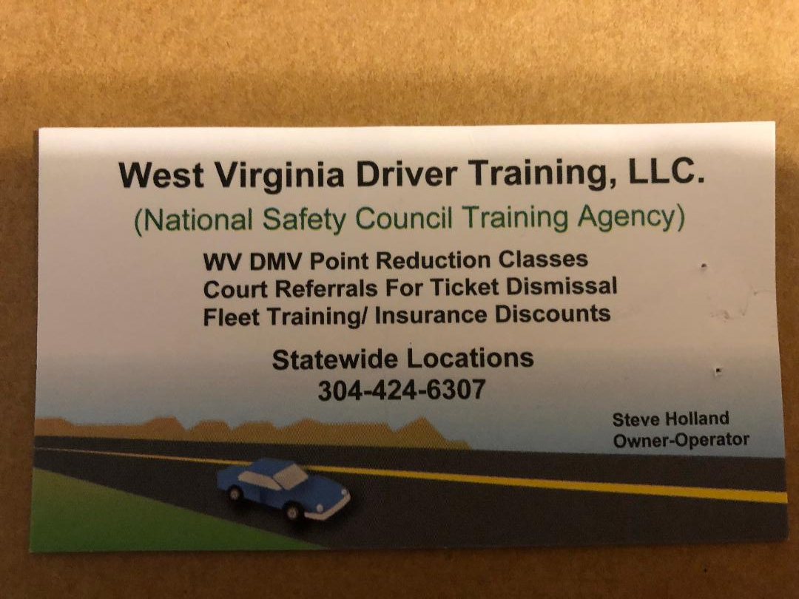

Events/Fundraisers:
Our Sam’s club education table held September 28, 2019 was a huge success. A total of $396.49 was donated for our spay/neuter fund and several large bags of cat food. Congratulations to Stephanie Canfield our door prize winner. She won our cat wine basket and hand painted greeting cards that were donated by Ann Kendall Morris of Charleston. Thank you, Ann, for the beautiful cards. Thank you everyone who came to our education table to support our mission and learn about our TNR program.

Thank You!
Save a Kitty is the proud recipient of the “Best Friends Rachel Ray, Save them all grant” in the amount of $7,000. The grant will assist with the sterilization and vaccination of 200 community cats and kittens. We are elated that Best Friends is a dedicated sponsor for sterilizing community cats. Everyone knows that spay/neuter is the only humane method of controlling cat over-population. We commend this awesome group for believing these healthy cats and kittens are part of the community and that they deserve to live their lives happy and healthy. These cats and kittens do not belong in shelters or rescues. They do not thrive indoor and many are too scared to be close to humans. They do appreciate a warm meal and shelter!! Most shelters are providing spay/neuter for community cats, so they can be returned to their outdoor homes. Most grantors have stopped supporting shelters who don’t. Thank you, Best Friends Animal Society and Rachel Ray!!!

Cat Zoomies !!
Does you cat or kitten get the “late night zoomies?” Most cat owners have experienced cat zoomies ranging from post-litter box “victory laps” to late-night hallway rodeos. As with all things feline, there is a method to their madness! It all comes down to instinct. Here are a few reasons that cats experience these late-night cardio sessions:

They’re in hunting mode! Cats are natural crepuscular, meaning that they are most active at dawn or dusk. For a cat in the wild, this is an ideal time to stalk and hunt their prey. Your housecat has the same powerful instinct.

They’re bored! They might be releasing all that pent-up energy that hasn’t been spent hunting or playing throughout the day. Cats are predators at heart and rely on the act of hunting (or play hunting) to stimulate their mental instincts and desires. If zoomies happen frequently, try spending 15 minutes per day to play with your kitty. A wand or teaser toy and a laser pointer are great toys for cats and kittens.

They are actually hunting! Many prey animals are nocturnal-like mice and insects. Your kitty might be reacting to prey animals they can hear or sense that you can’t. A cat’s sense of hearing is five times stronger than your own! Their sensitive ears allow cats to distinguish how big or small a prey animal is and detect the size of prey or even a predator!

Working hard to help community cats.
We are elated to have been able to help well over 400 cats and kittens in 2019. Unfortunately, spay/neuter has slowed down due to the temporary closing of the local Spot clinic. The Spot clinic is searching for a new Veterinarian. Until that time, our spay/neuter appointments are at a minimum. With over 200 cats and kittens still on our “surgery waiting list”, it will take some time to get to all of the caretakers who have applied for assistance. We apologize for the delay in helping all caretakers’ but it is out of our hands. We are always working to acquire funding to pay for surgeries/vaccines or seeking Veterinarians’ to help with our community cat surgeries.

Combined Federal Campaign
Save a Kitty FCP has once again been chosen to participate in the Federal employees combined federal campaign. If you care about the welfare of cats’ in our community, please consider donating to Save a Kitty via payroll deduction or even a one-time gift. Our CFC identification number is #97560. We appreciate all of the help we have received over the last several years! You have made a huge difference in the lives of community cats and kittens. Your gift helps fund their spay/neuter surgeries and vaccinations. They live healthier, longer and happier lives through this effort. Thank you!

PACF
Save a Kitty is also a member of the Parkersburg Area Community Foundation. Help secure the future of many cats who still need our help by donating to the PACF.

