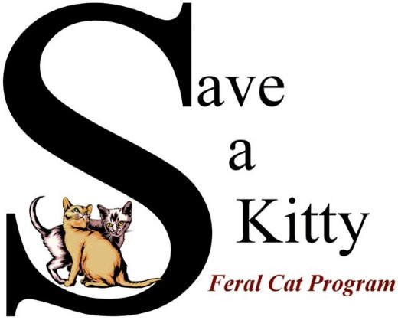
Ways To Support Save a Kitty Feral Cat Program
Chewy.com
Save a Kitty is listed on Chewy.com for cat food donations under our wish list. Just search for Save a Kitty Feral Cat Program if you wish to donate and help feed less fortunate community cats.
Kroger Community Rewards
Kroger will donate to Save a Kitty each time you shop if you choose Save a Kitty Feral Cat Program as your non-profit. This is at no cost to you! Sign up at Kroger.com and list your Kroger rewards card number at the following link to enroll: https://www.kroger.com/i/community/community-rewards Our organization code is QP442.
Amazon Smile
Amazon Smile is simple to use and you will automatically support Save a Kitty every time you shop, at no cost to you! When you shop Amazon through the following link: smile.amazon.com you will find great items at great prices while supporting Save a Kitty. Amazon will donate a portion of your purchase price to our program. Search for Save a Kitty Feral Cat Program through smile.amazon.com and help sterilize and vaccinate less fortunate community cats.
Monetary Donations
Save a Kitty FCP raises funds through our compassionate supporters and by holding various fundraisers throughout the year. If you would like to help by contributing to our spay/neuter program our address is: Save a Kitty FCP, PO Box 1442, Parkersburg, WV 26102. You can also donate through our website at www.saveakitty.org which accepts credit cards and PayPal donations. We are also on Facebook under Save a Kitty Feral Cat Program, Inc.
Volunteers needed
If you would like to volunteer, we have many opportunities! We always need caring people to help feed cat colonies, help with fundraisers or the many other things we do for community cats. Please contact Alice Rolette, Volunteer Coordinator at 304.893.7503
Save a Kitty Feral Cat Program is a 501©3 tax-exempt, non-profit organization. Donations are tax deductible to the extent allowed by law. Thank you for helping community cats.

