President’s Corner:
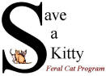
SAVE A KITTY FERAL CAT PROGRAM, INC.

Publisher SAK Volunteers Volume No. 16 Issue No. 4 Date 4th Qtr 2019
Parkersburg, WV NEWSLETTER www.saveakitty.org

Progress!
Year 2019 resulted in 473 spay/neuters of community cats who are cared for by compassionate residents. This included 266 female spays and 207 male neuters!!! Talk about impact on cat over-population. Not only are these felines no longer reproducing but they are living much happier and healthier lives! Since our inception in June 2004, 7,515 community cats have been altered and vaccinated. Our TNR program has directly impacted the cat/kitten intake and euthanasia of cats and kittens entering the local shelter. Healthy community cats/kittens should be sterilized and vaccinated and returned to their outdoor living area. Daily feeding and providing shelters are the humane thing to do. Community cats are often destroyed because they are not adoptable. A humane community will not let this happen!

Save a Kitty (Medical Program)
Each year, Save a Kitty receives many “calls for help” for community cats who are sick or injured. Knowing that these cats’ will sometimes need assistance, we created our medical program to assist when funds are available. The success of the program is dependent on fundraisers and generous donations from the public. We have helped many cats’ with upper respiratory, abscesses, general illness and even amputations. Please consider donating to Save a Kitty if you would like to help. Mark your donation, “medical fund” and we will continue to care for cats in need, as funds are available.

Hollie-Our 3-legged kitty!
After many reports of an injured cat in the South Parkersburg Walmart parking lot, Save a Kitty had to help! Poor Hollie had been dragging her back leg around for who knows how long due to a pelvic fracture! She was finally caught and taken to Emergency Vets, where she had to have her leg amputated. Her life will be much better and “pain-free” now that she had surgery. We are working hard to raise funds to pay for her amputation and hospital stay. She is a much happier kitty now and not searching for food in the cold. She is currently in a foster home and she is thriving. If you would like to donate towards Hollie’s care, you can mail your tax-deductible donation to Save a Kitty, PO Box 1442, Parkersburg, WV 26102. Please mark it “Hollie” and thank you for helping less fortunate cats in the community.
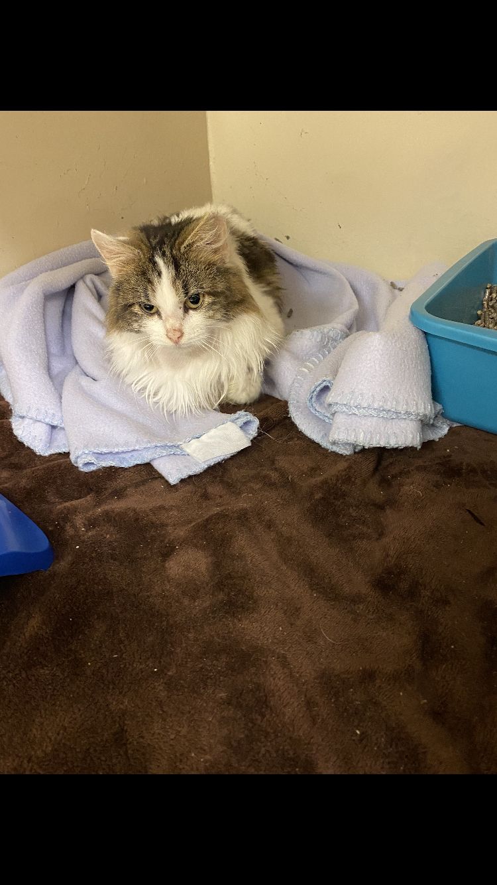
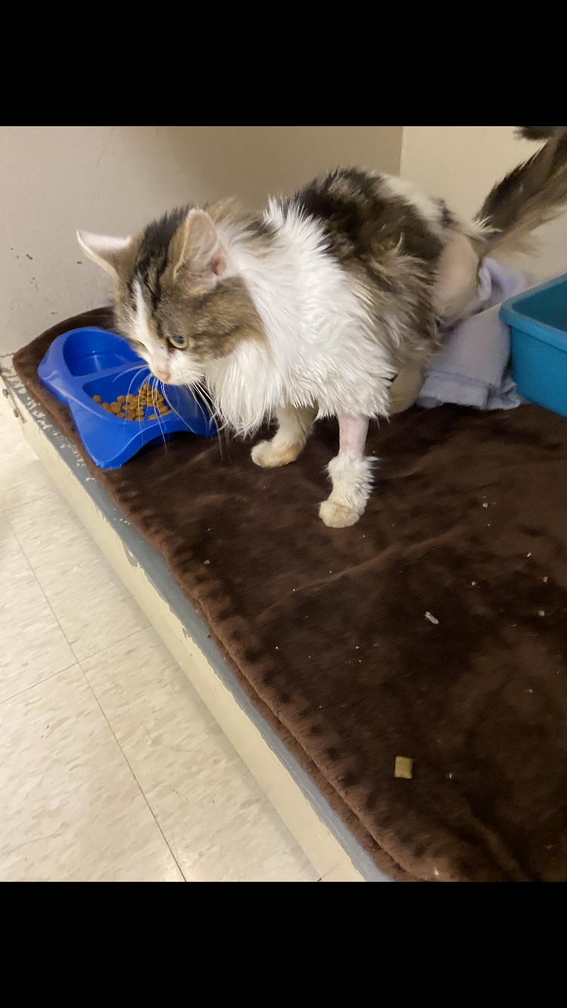
Thank you for advertising with Save a Kitty FCP!
We appreciate your support of the businesses who advertise with Save a Kitty. WV Driver Training, LLC is a National Safety Council Training Agency. If you require point reduction classes, fleet training/insurance discounts or court referrals for ticket dismissal please contact WV Driver Training, LLC at the number indicated.
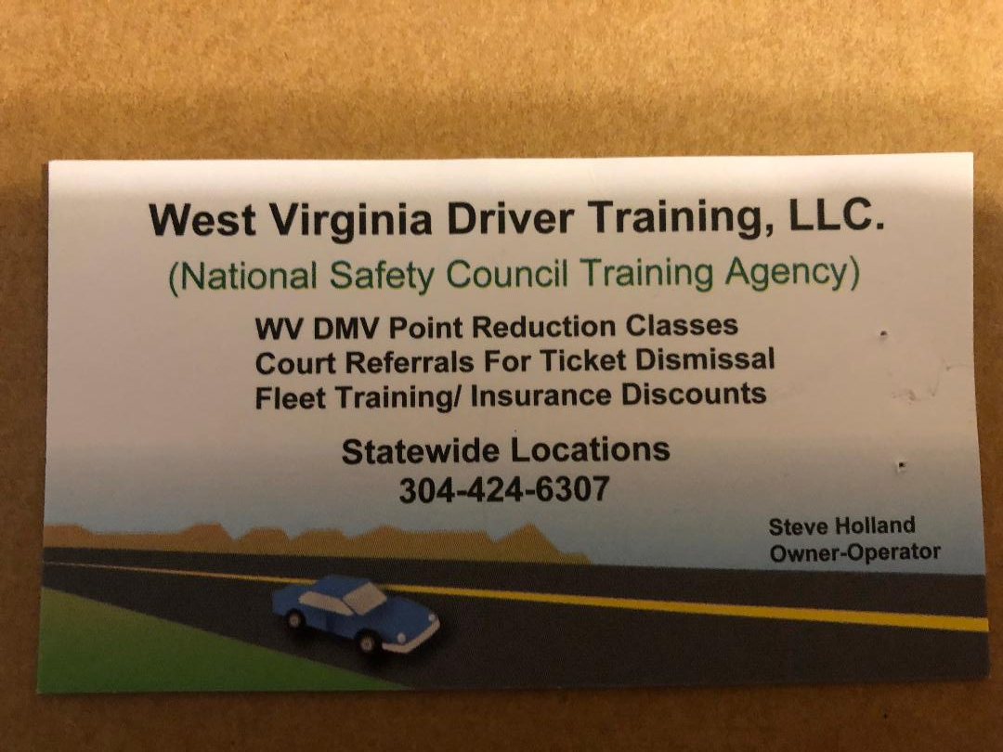

Events/Fundraisers:
Our 2nd annual “Designer Purse Bingo”, will be held on a Saturday at the Moose Club. This event raised several thousand dollars for our spay/neuter program in 2019. The event date and more details will be posted on our Facebook page soon. We hope to see you there!

June 13, 2020- Sam’s Club education table from 10 am to 4 pm.

Working hard to help community cats.
We are elated to have been able to help almost 500 cats and kittens in 2019. Unfortunately, spay/neuter has slowed due to the temporary closing of the local Spot clinic. The Spot clinic is searching for a new Veterinarian. Until that time, our spay/neuter appointments are at a minimum. With over 200 cats and kittens still on our “surgery waiting list”, it will take some time to get to all of the caretakers who have applied for assistance. We apologize for the delay in helping all caretakers’, but it is out of our hands. We are always working to acquire funding to pay for surgeries/vaccines or seeking Veterinarians’ to help with our community cat surgeries.

Combined Federal Campaign
Save a Kitty FCP has once again been chosen to participate in the Federal employees combined federal campaign. If you care about the welfare of cats’ in our community, please consider donating to Save a Kitty via payroll deduction or even a one-time gift. Our CFC identification number is #97560. We appreciate all of the help we have received over the last several years! You have made a huge difference in the lives of community cats and kittens. Your gift helps fund their spay/neuter surgeries and vaccinations. They live healthier, longer and happier lives through this effort. Thank you!

PACF
Save a Kitty is also a member of the Parkersburg Area Community Foundation. Help secure the future of many cats who still need our help by donating to the PACF. The community cats need your support!

