President’s Corner:
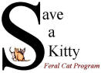
SAVE A KITTY FERAL CAT PROGRAM, INC.

Publisher SAK Volunteers Volume No. 17 Issue No. 4 Date 4th Qtr 2020
Parkersburg, WV NEWSLETTER www.saveakitty.org

A business who loves cats! That is a business we patronize and appreciate! Say hello to Oatmeal and Shar! These handsome boys are permanent residents of our local Park Hardware. They are approximately 3 years old and are official greeters at the store. They were adopted as kittens from a customer who could not keep them. Park Hardware is a local hardware and plumbing store which opened in the Parkersburg area in 1953. We appreciate Park Hardware’s kindness to these cats and the many customers who patronize their store.
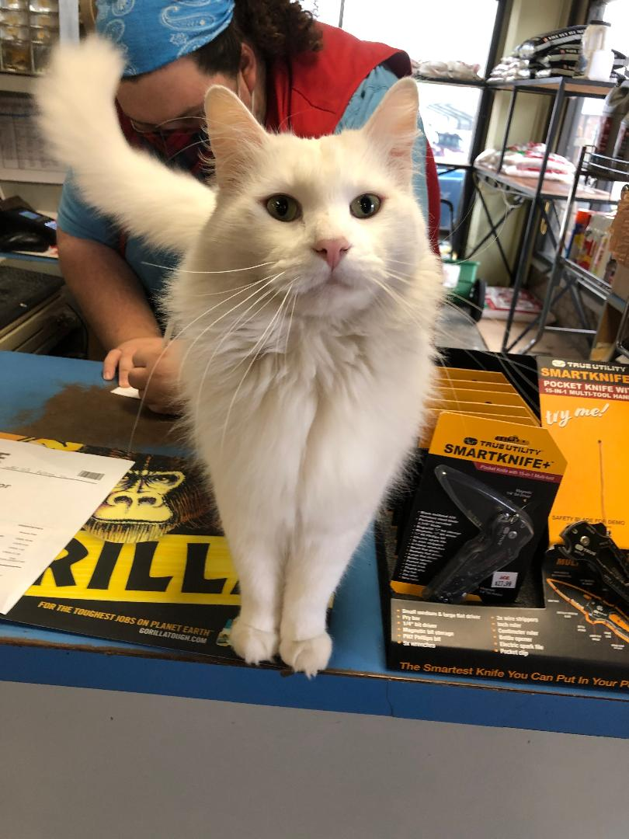
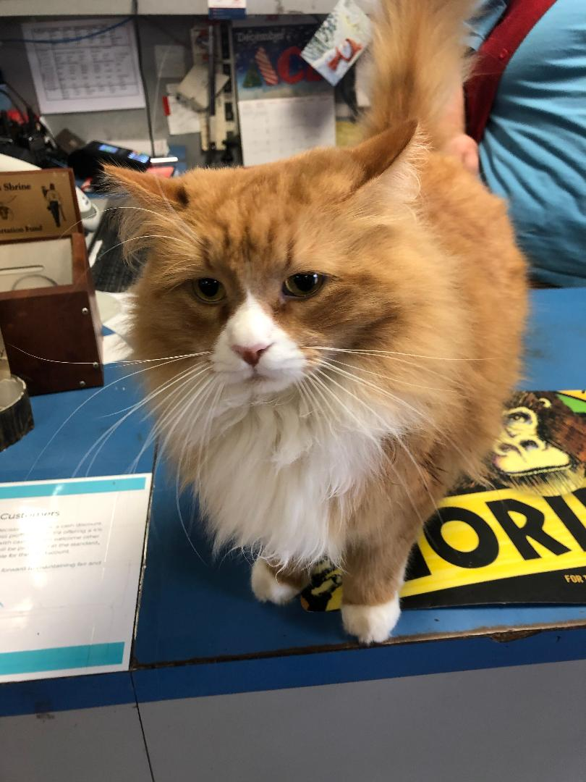

1st annual Fix a Kitty 300 club raffle
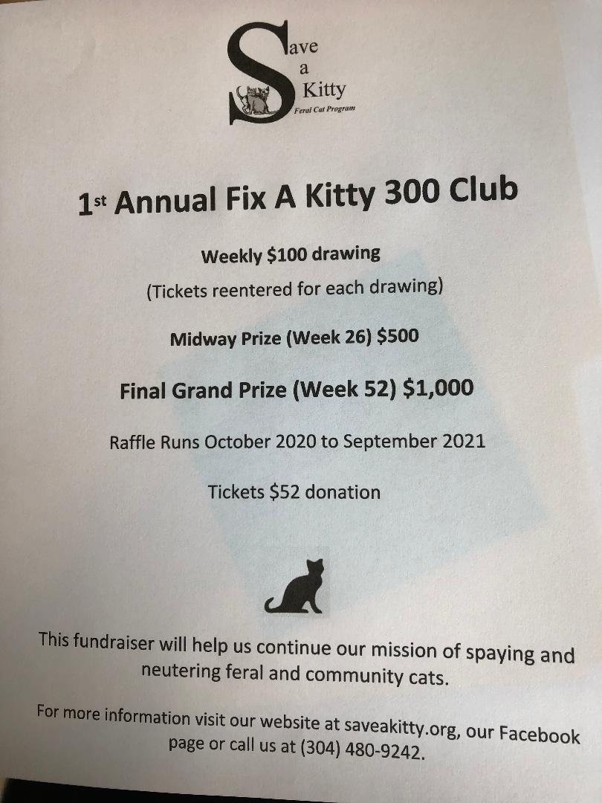
Our “Fix a Kitty 300 Club” event is one of the few fundraisers we will hold this year due to Covid-19. We would appreciate your support in purchasing a ticket! The funds raised will go directly to support our spay/neuter mission and possibly medical care for injured or ill community cats and kittens. Tickets are being sold at Buttermore Jewelers, Mulberry Lane and Bullseye Antiques. You can also mail a check to Save a Kitty, PO Box 1442, Parkersburg, WV 26102 with “300 club raffle” in the memo line. Cost is $52. Weekly drawings are $100 winners. Week 26 is a $500 winner and week 52 is a $1,000 winner. We will mail your ticket stub directly to you. Weekly winners will be re-entered for each drawing. You have multiple chances of winning!! The first drawing will be Wednesday, October 7, 2020 but we will continue to sell tickets. Thank you for your support!

Remember me?
We thought you would enjoy an update on May (formerly known as Hollie) who was rescued from the South Parkersburg Walmart parking lot. She had somehow been injured, dragging a back leg and needed our help. Many of you donated to her much need medical care. She received surgery to remove her badly mangled leg and all the medical care she needed. This is May, enjoying her new home with Brenda Leavitt and her cat and dog companions. As you can see, she is extremely happy and healthy with 3 legs and she loves her first Christmas tree. Thank you again to everyone who donated to her medical fund to make her life happier and healthier. We are extremely grateful to Brenda for adopting her and showing her the love she deserves.
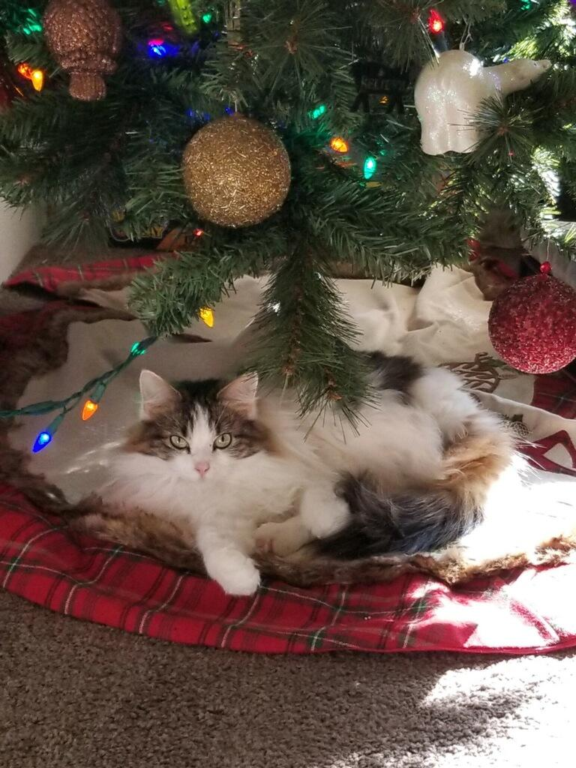

Chewy.com
Save a Kitty Feral Cat Program is now part of the shelter/rescue wish list at Chewy.com. Sign in to Chewy.com and you can donate much needed food or gift cards to purchase these items for community cats in need. Just choose Save a Kitty Feral Cat Program, Inc. from the shelter/rescue list and then view our wish list. We also receive a referral payment if you are a first-time customer. We appreciate your kindness in donating to the less fortunate cats, who live outdoor in our community. Nutritious food daily keeps outdoor cats’ healthy and happy.

If you would like more information on Save a Kitty Feral Cat Program, check out our website at www.saveakitty.org or http://www.facebook.com/Saveakittyferalcatprograminc

